R.No: 4 | Reg. No: 192324305 | Name: AYESHA SIDDIQA S
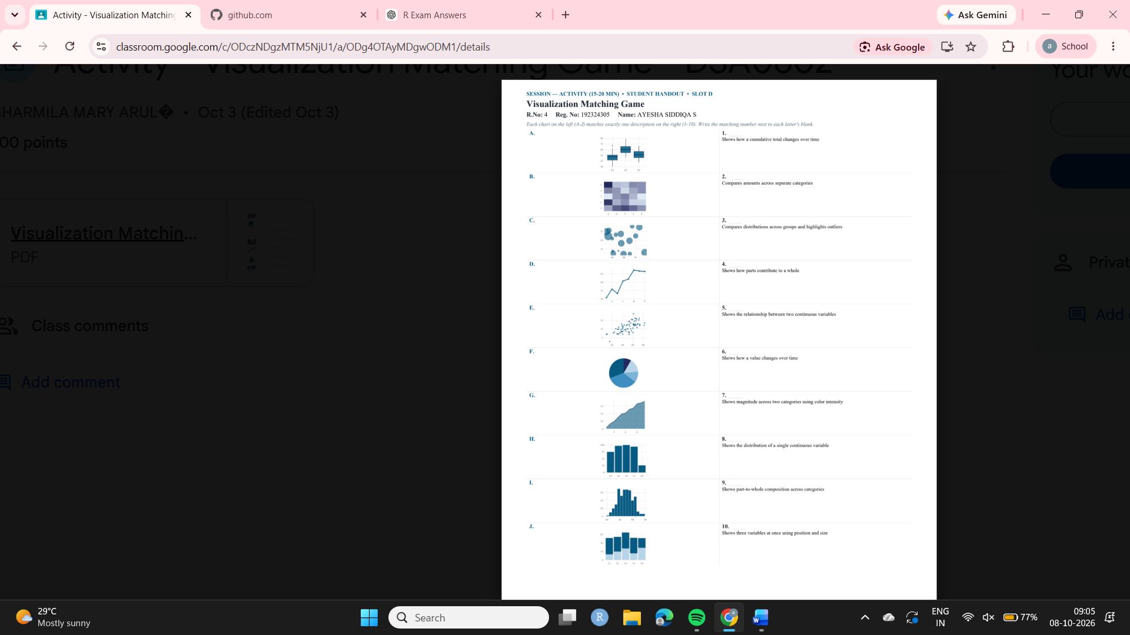
Visualization Matching Game
Chart | Matching No. | Description
A | 3 | Compares distributions across groups and highlights outliers
B | 7 | Shows magnitude across two categories using colour intensity
C | 10 | Shows three variables at once using position and size
D | 6 | Shows how a value changes over time
E | 5 | Shows the relationship between two continuous variables
F | 9 | Shows part-to-whole composition across categories
G | 1 | Shows how a cumulative total changes over time
H | 2 | Compares amounts across separate categories
I | 8 | Shows the distribution of a single continuous variable
J | 4 | Shows how parts contribute to a whole

